National Textile University, Faisalabad

Department of Computer Science

Name: | Nimra Tanveer
Class: | BSSE A 5th
Registration No: | 23-NTU-CS-1201
Assignment: | Lab 13
Course Name: | Operating Systems
Submitted To: | Sir Nasir Mahmood

Lab task:

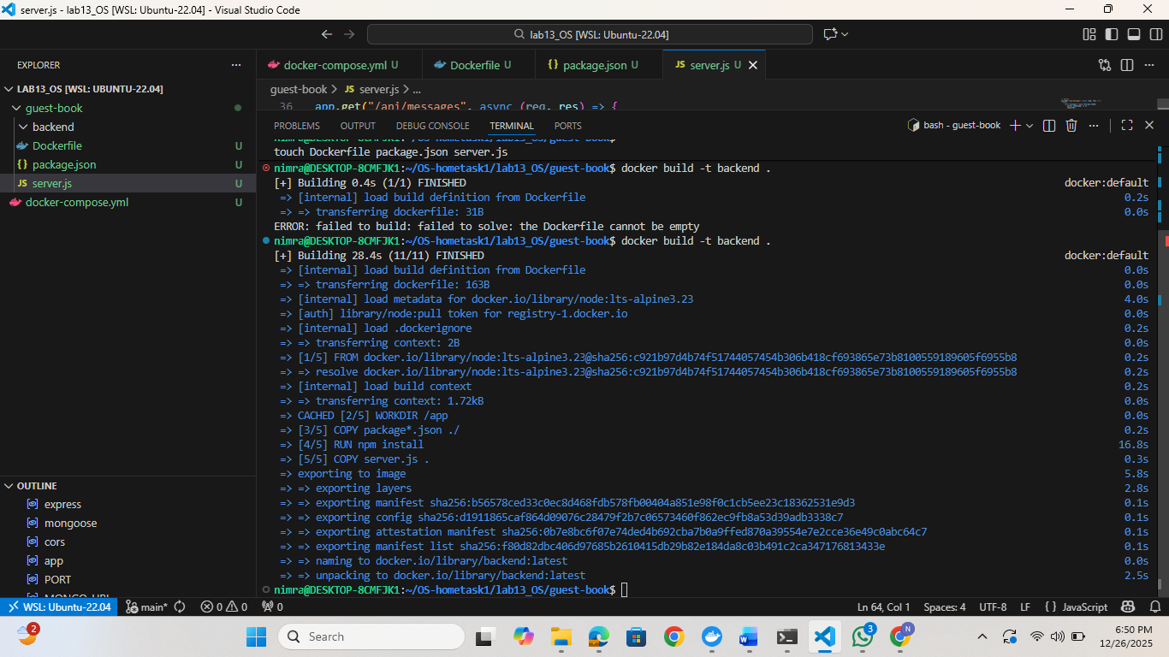
Command related to making guest-book folder, backend folder and its image

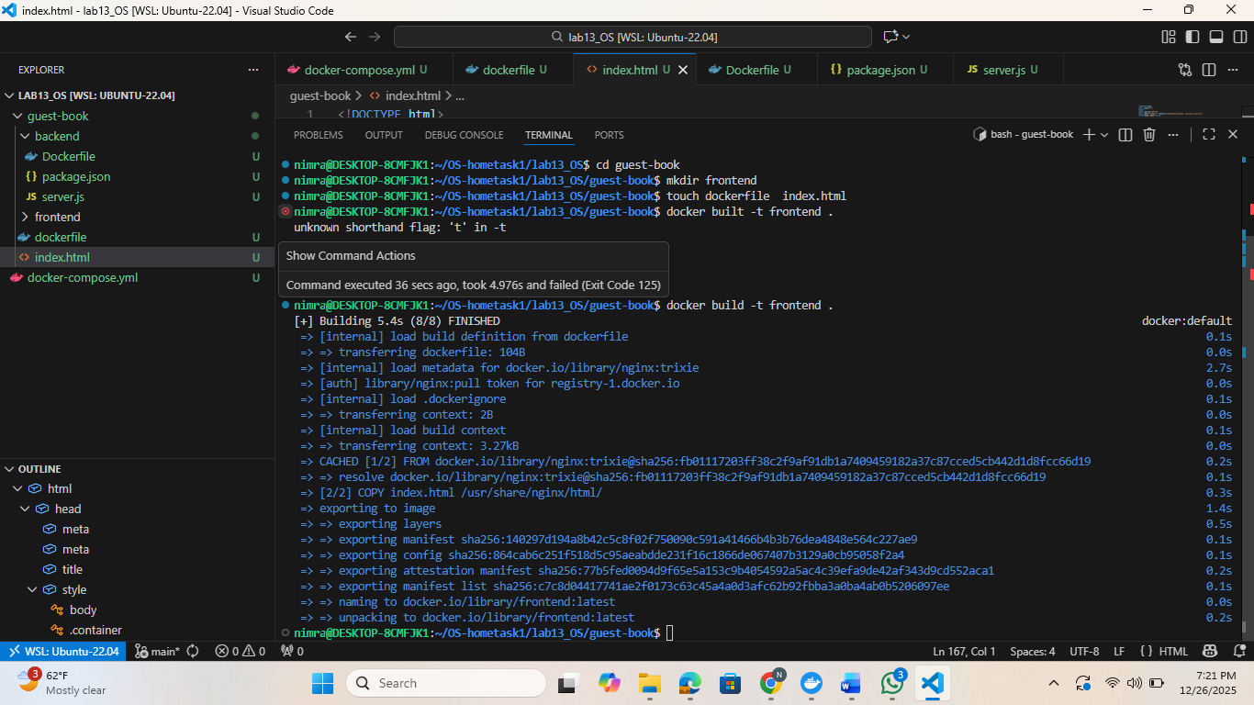command related to frontend folder and its image

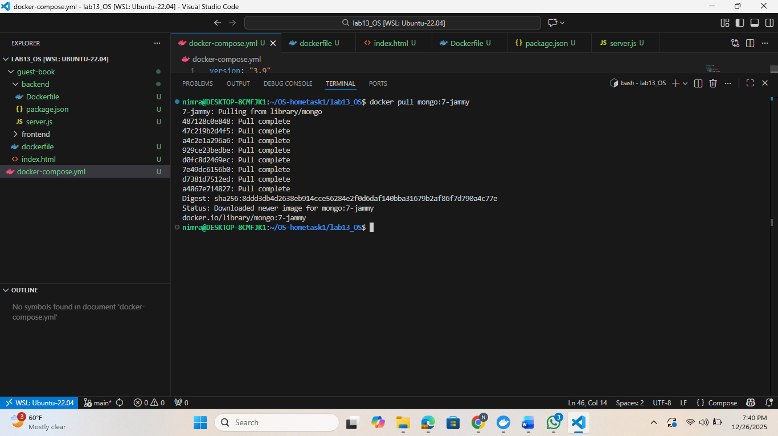
Command to downland mongo:7-jammy
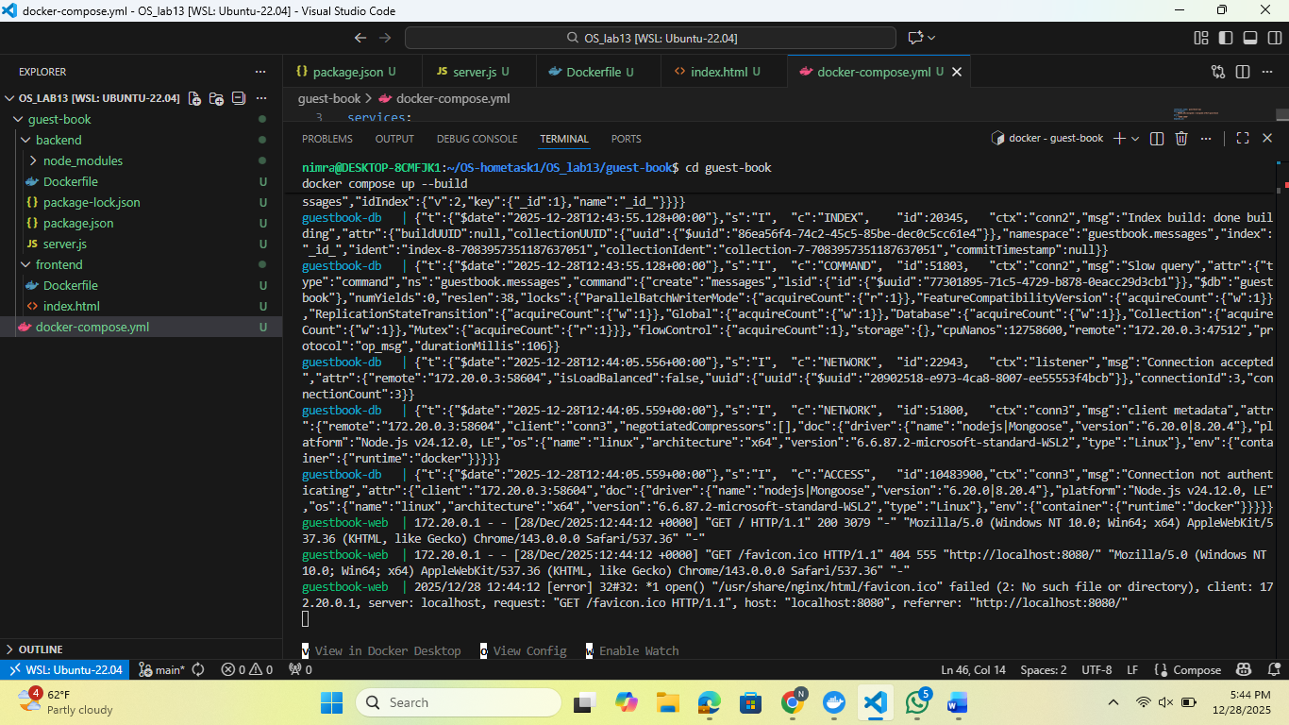
After running command cd guestbook docker compose up –build

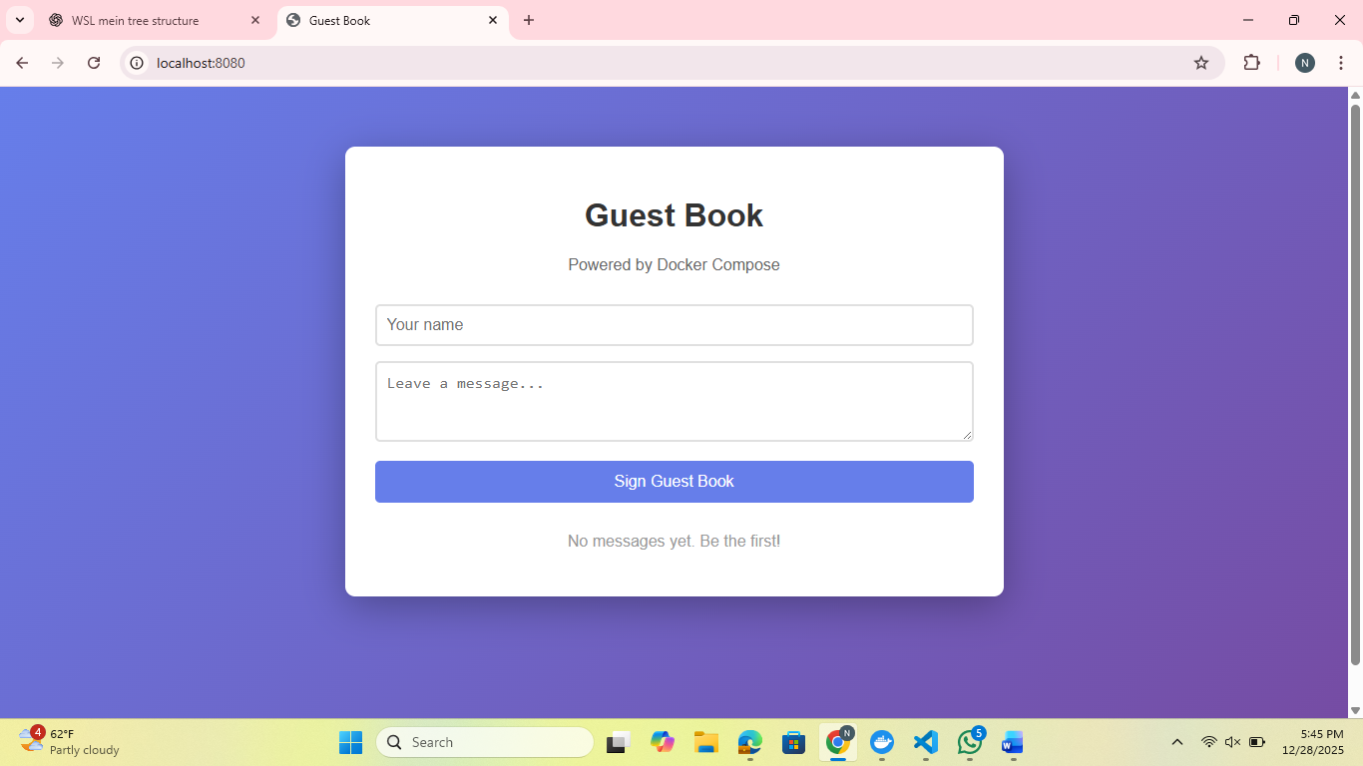
After visiting Visit: http://localhost:8080

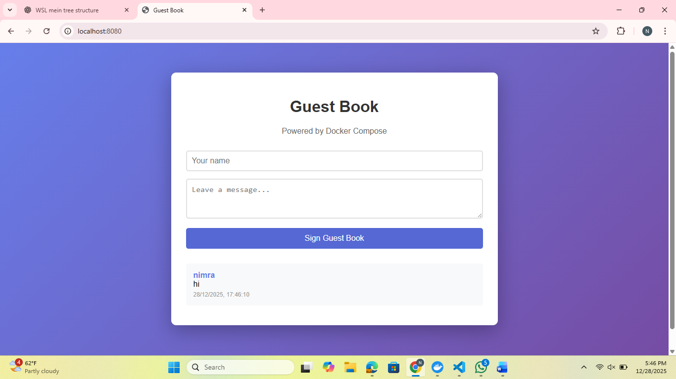

Enter your name and a message and getting this output .

